**Week_2 Activity**

**Team 7**

**Samagnya Erri**

**Bhargavi Indla**

**Lahari Gurram**

**Bhanurekha Gaddam**

**Shashank Gurrapu**

**Department of Information Systems, Saint Louis University**

**IS-5500-22, Advanced Software Development**

**Professor: Chandra Prakash Bathula**

**Diagram**

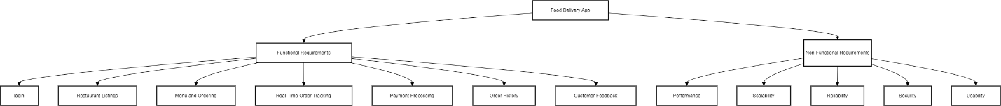

graph TD

A[Food Delivery App] --> B[Functional Requirements]

A --> C[Non-Functional Requirements]

B --> D[User Registration & Authentication]

B --> E[Restaurant Listings]

B --> F[Menu and Ordering]

B --> G[Real-Time Order Tracking]

B --> H[Payment Processing]

B --> I[Order History]

B --> J[Ratings and Reviews]

C --> K[Performance]

C --> L[Scalability]

C --> M[Reliability]

C --> N[Security]

C --> O[Usability]

C --> P[Compatibility]

C --> Q[Compliance]

style B fill:#87ceeb

style C fill:#ff6347

style D fill:#ffffff